* Event.target returns a node that was targeted by the function. We can see all the properties of the node by console.dir(e.target)
* QuerySelctor returns a node, queryselectorall returns a nodelist.
* In case of assigning a javascript event listener, we should always add if block first to avoid errors in case we want to share the script with multiple pages. Cause it will not find all elements in all pages and script wont run.

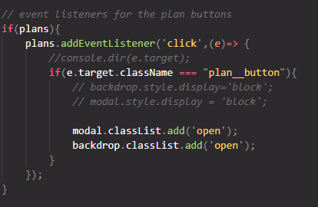

* We should always check the console for erros.

To assign a style we can have different approach,

1. **Use inline style**: for example. we can select the object and set the style. Button.style.display = ‘none’
2. **Use className**: we can do this when the element has no other class or we want to replace classes with our class. Button.className = ‘open’ will replace all classes of button with the class open.
3. **User ClassList:** this property has bunch of methods like add, remove etc. we can use them easily to append classes or remove. It has bunch of other methods as well which helps us with iteration or logic. Button.classList.add(‘open’)